Query #1

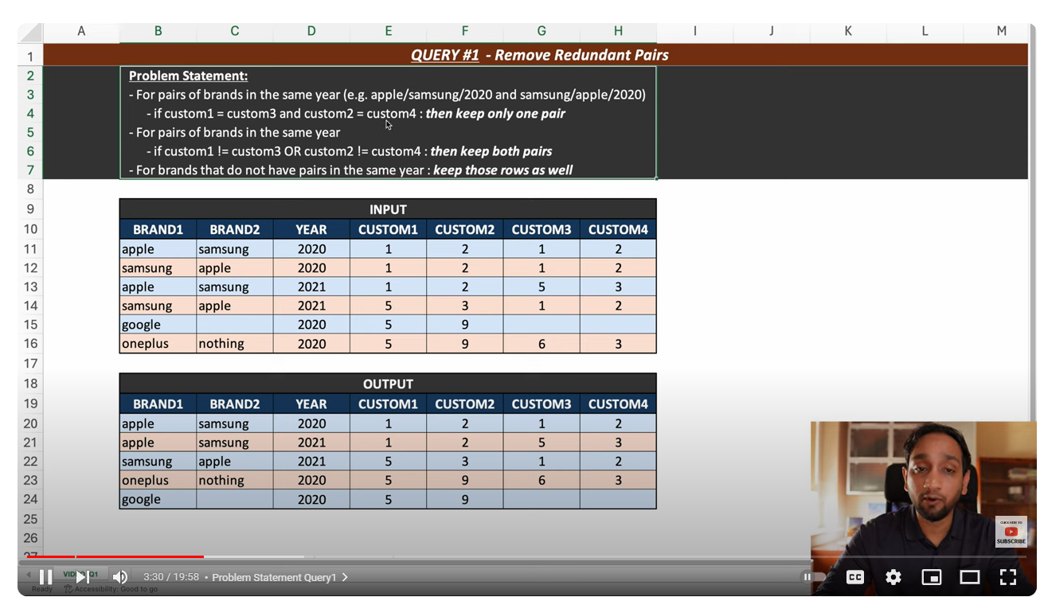

INSERT INTO public."queryOne_brands"(

brand1, brand2, year, customer1, customer2, customer3, customer4)

VALUES

('alex', 'ava', '2023', 2, 2, 2, 2),

('ava', 'alex', '2023', 2, 2, 2, 2),

('apple', 'samsung', '2020', 1, 2, 1, 2),

('samsung', 'apple', '2020', 1, 2, 1, 2),

('apple', 'samsung', '2021', 1, 2, 5, 3),

('samsung', 'apple', '2021', 5, 3, 1, 2),

('google', '', '2020', 5, 9,0,0 ),

('oneplus', 'nothing', '2020', 5, 9, 6, 3)

;

select * from public."queryOne_brands";

with pairs_year as(

select *,case when brand1<brand2 then concat (brand1,brand2,year)

else concat(brand2,brand1,year) end as mark_value

from public."queryOne_brands" a

),

brand_rn as (

select * ,row_number()over(partition by mark_value) rn

from pairs_year

)

select brand1,brand2,year,customer1,customer2, customer3, customer4

from brand_rn where rn=1 or (customer1<>customer3 and customer2<>customer4);

Query2:

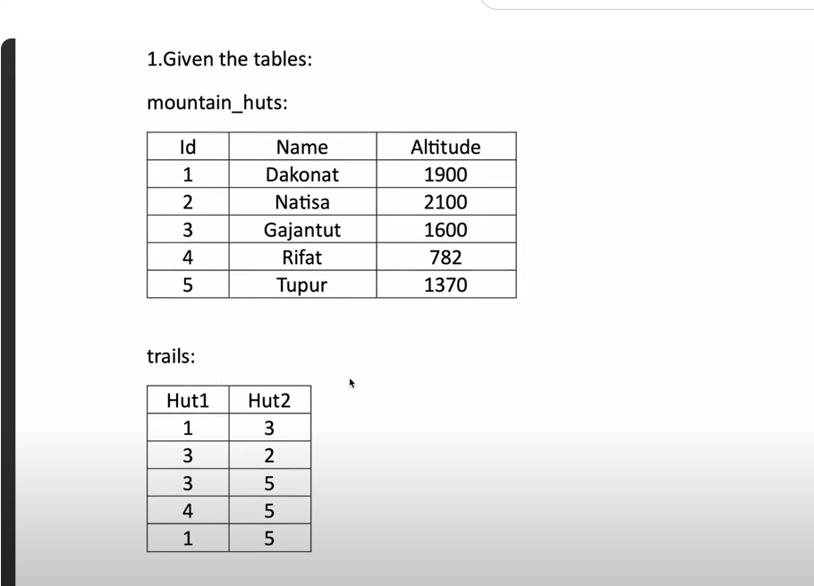

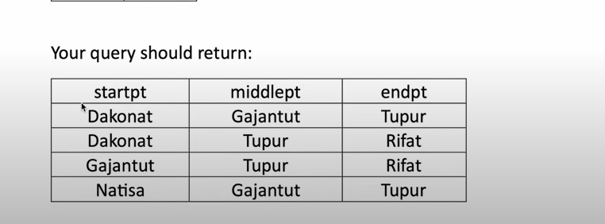



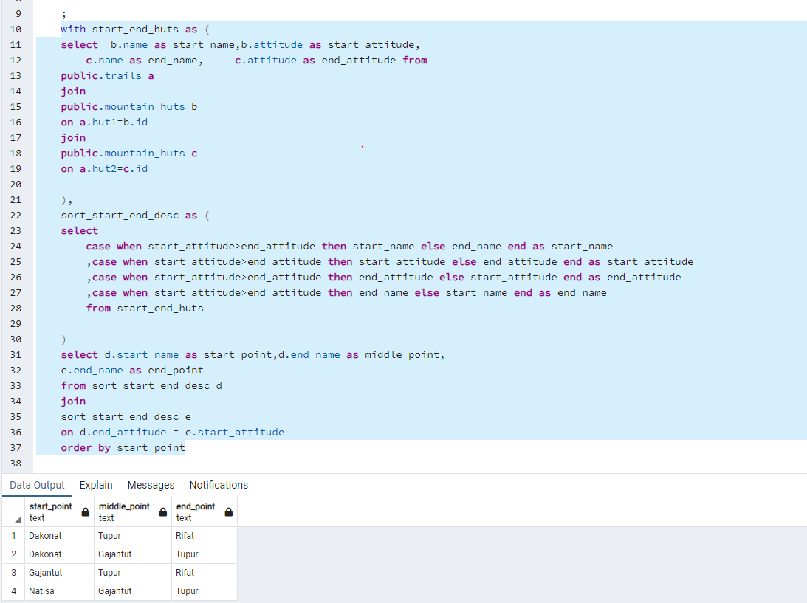

Query 3:

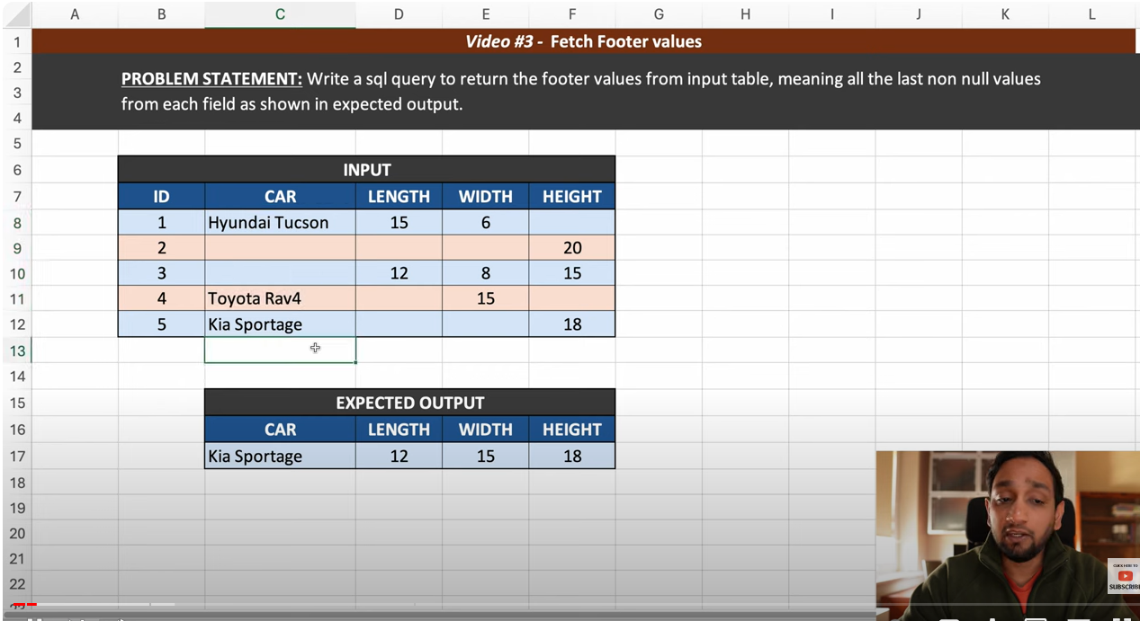

Based on your current role and skills, here's a list of areas you might consider learning or improving:

1. **Advanced SQL:** Since you're already working with SQL, enhancing your skills in this area could make you much more effective at testing and analyzing data. SQL is used heavily in the data world, and more complex knowledge such as stored procedures, triggers, and performance tuning can benefit you greatly.

2. **Learn More About Big Data Technologies:** Besides Spark, which you're already using, you might want to learn more about other big data technologies such as Hadoop, Hive, Pig, HBase, or Kafka. These technologies are commonly used in the big data ecosystem, and understanding them can make you more versatile as a data quality tester.

3. **Data Warehousing Concepts:** Understanding concepts such as ETL processes, data modeling, OLAP vs OLTP, star schema, and snowflake schema can help when working with big data systems.

4. **Python Programming:** Since you mentioned using PySpark and Pandas, you're probably already familiar with Python. Nevertheless, diving deeper into Python, especially aspects related to data manipulation and analysis (like NumPy, SciPy, Matplotlib for data visualization, etc.) could prove to be beneficial. Also, understanding Python's usage in the automation of testing scenarios might be helpful.

5. **Data Visualization Tools:** Tools like Tableau, Power BI, or QlikView can help you visualize data in a more digestible format, which is typically useful in noticing trends or anomalies.

6. **Testing Tools and Frameworks:** There are many tools and frameworks out there that can help automate and streamline the testing process. You might consider learning about tools such as JUnit, Postman (for API testing), Selenium (for web application testing), or Jest (for JavaScript testing).

7. **Understanding Machine Learning:** As big data and machine learning are closely intertwined, having a basic understanding of machine learning concepts can often be beneficial in a big data career.

Remember, the path to learning these skills depends on your goals, the needs of your projects, or the technologies your organization is invested in. It's a good practice to discuss this with your manager or team lead to align your learning path with the team's requirements.

Firstly  
 create extension if not exists tablefunc;



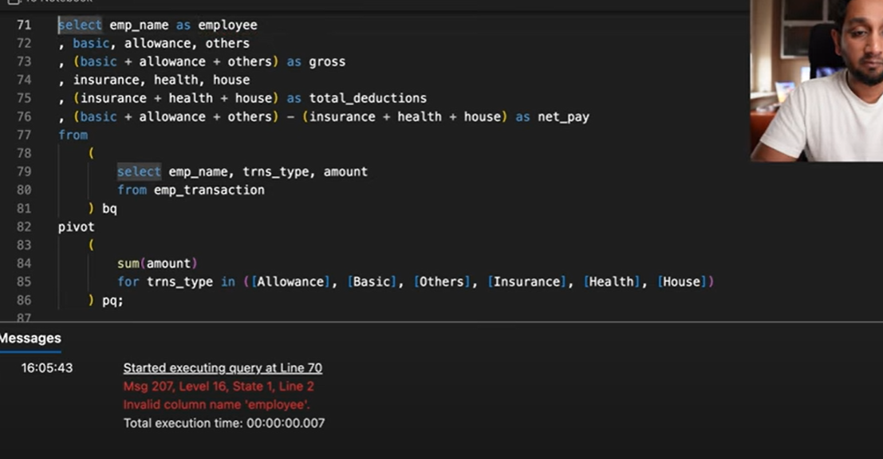

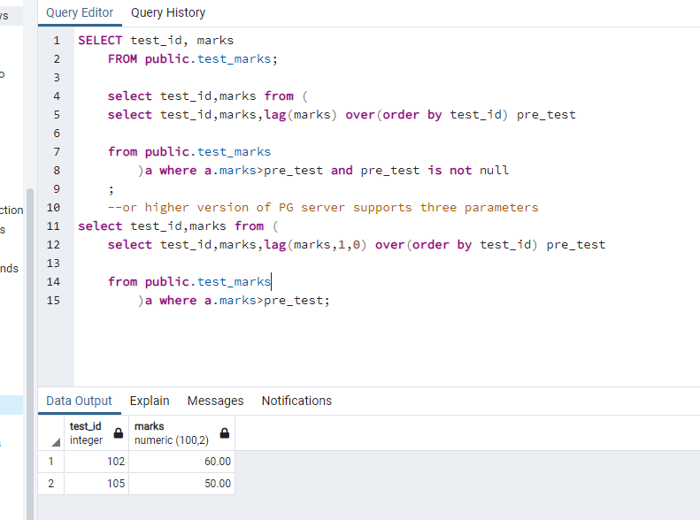

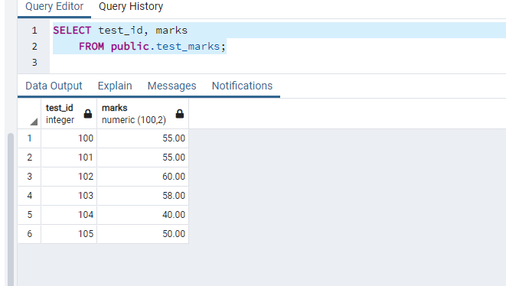

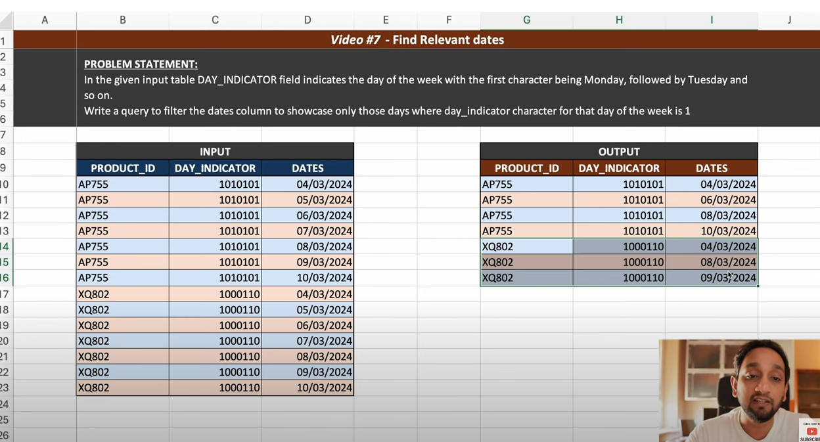

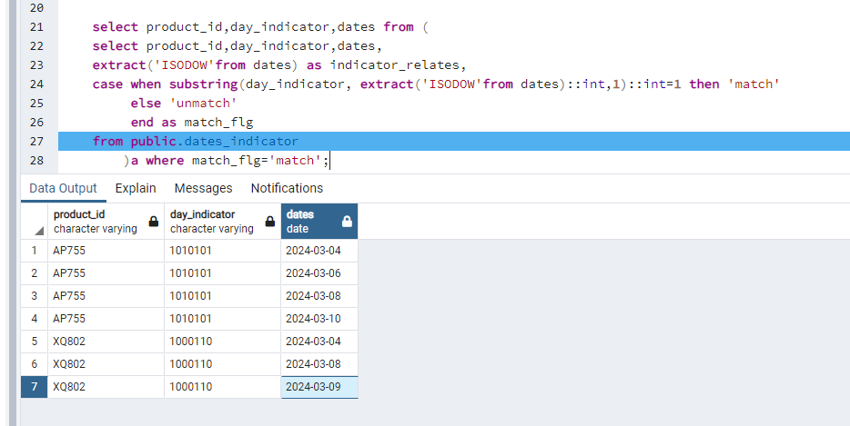

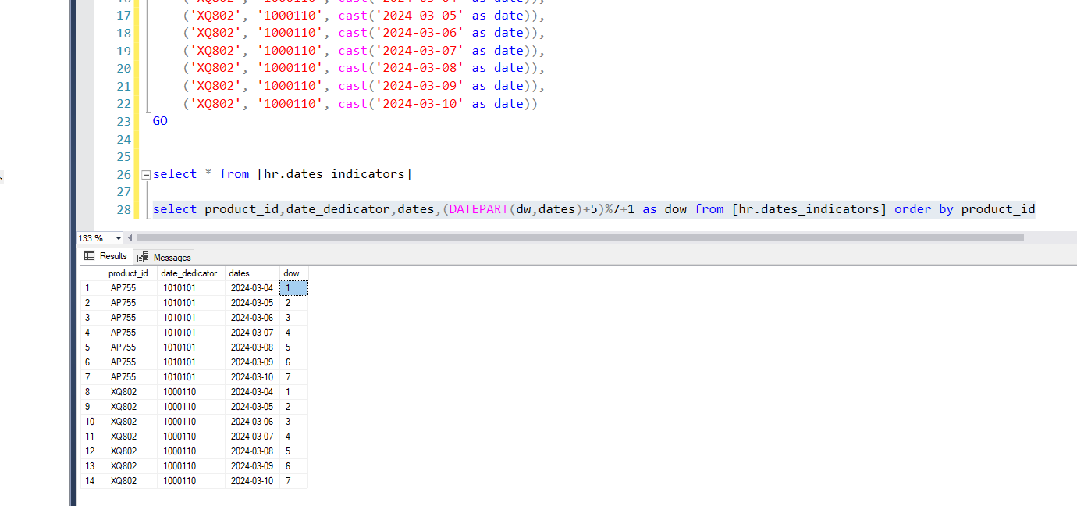

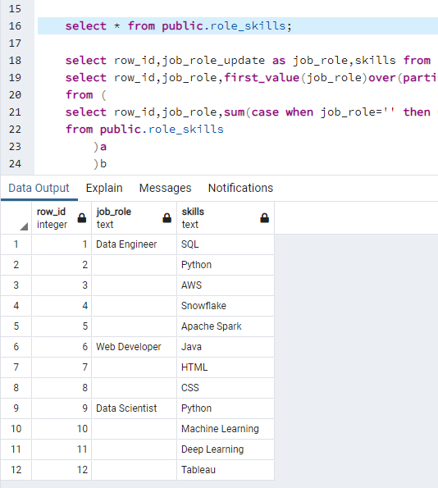

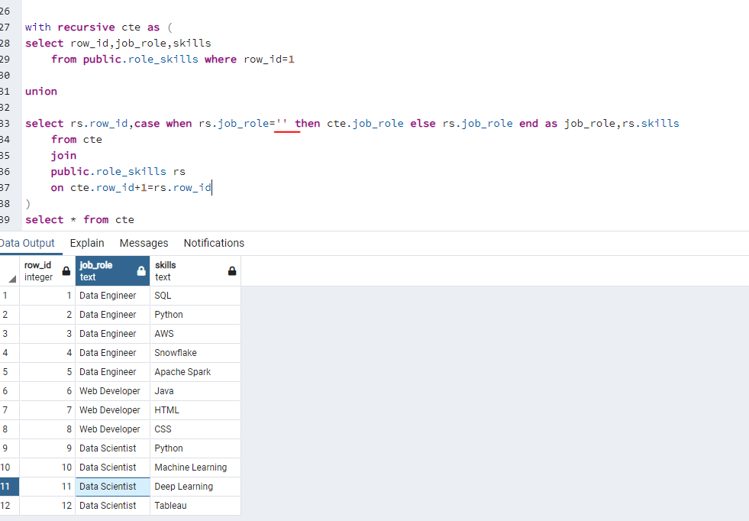

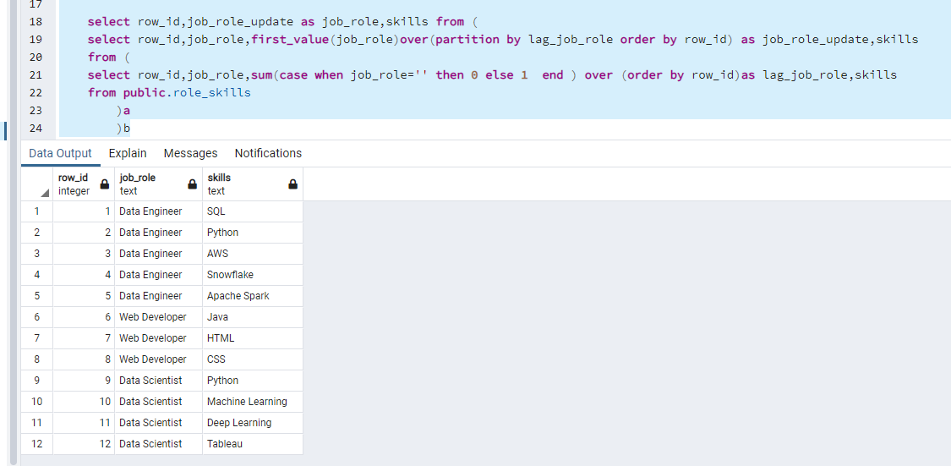

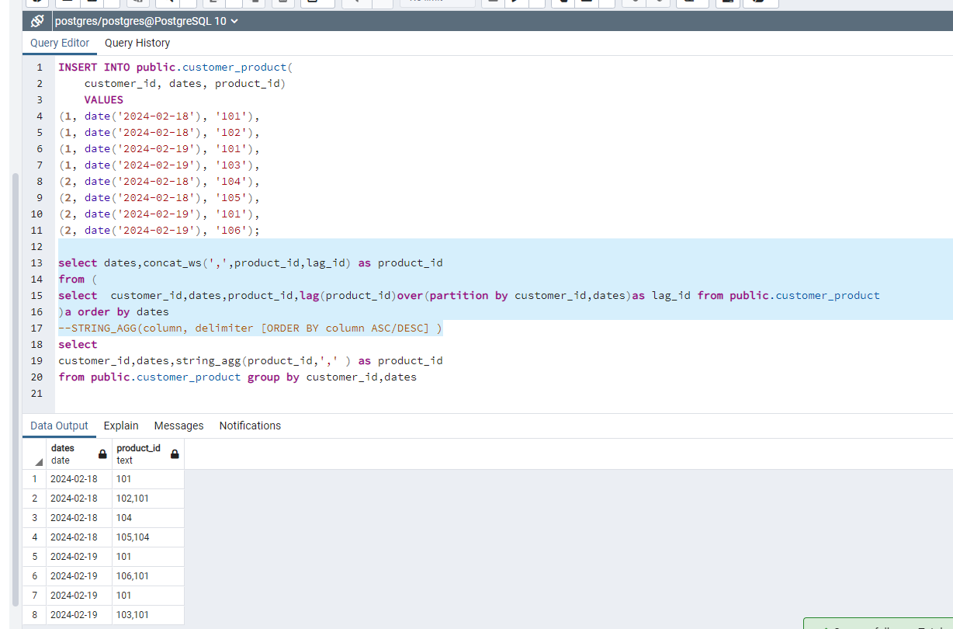

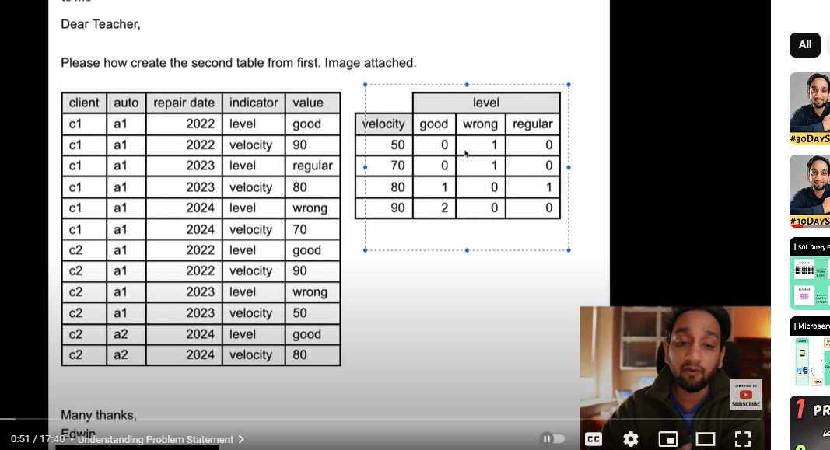

Using sqlserver pivot()

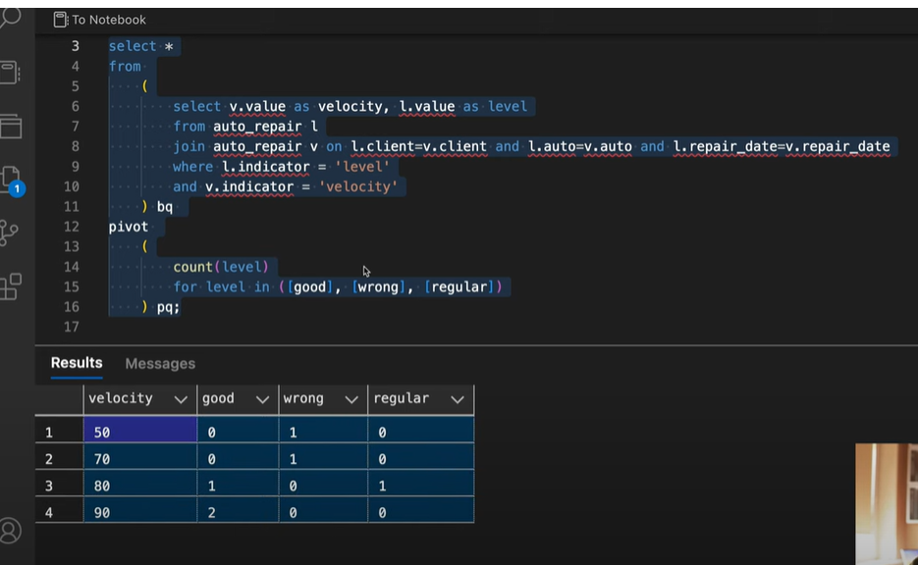

PG crosstab()

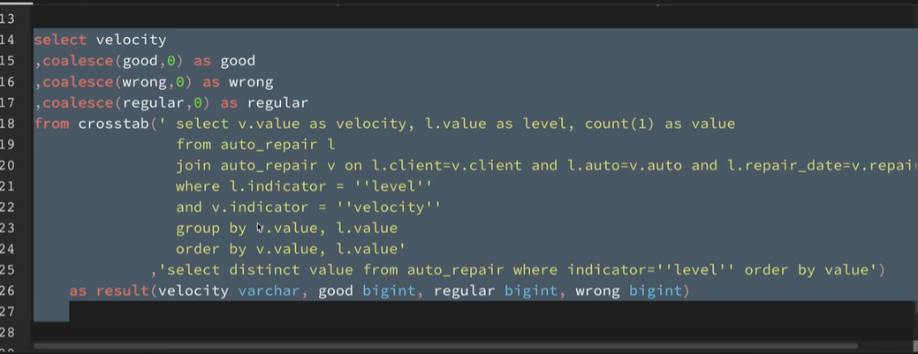

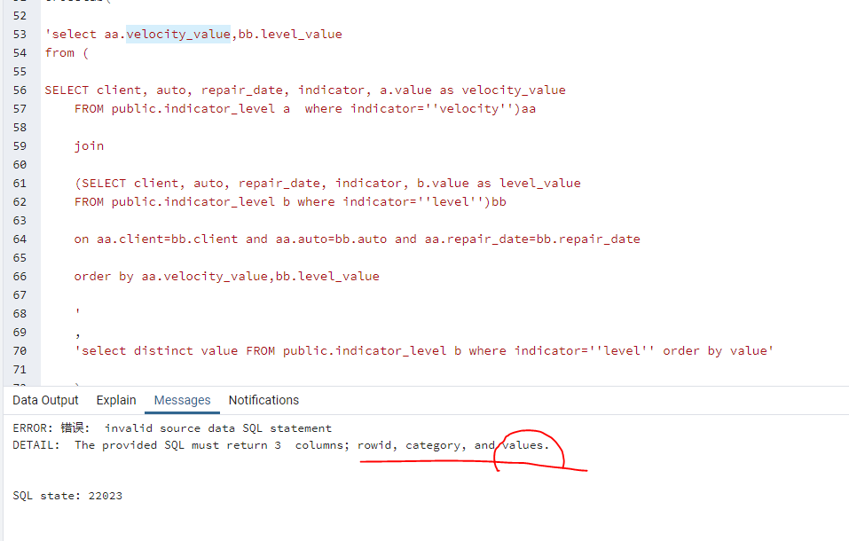

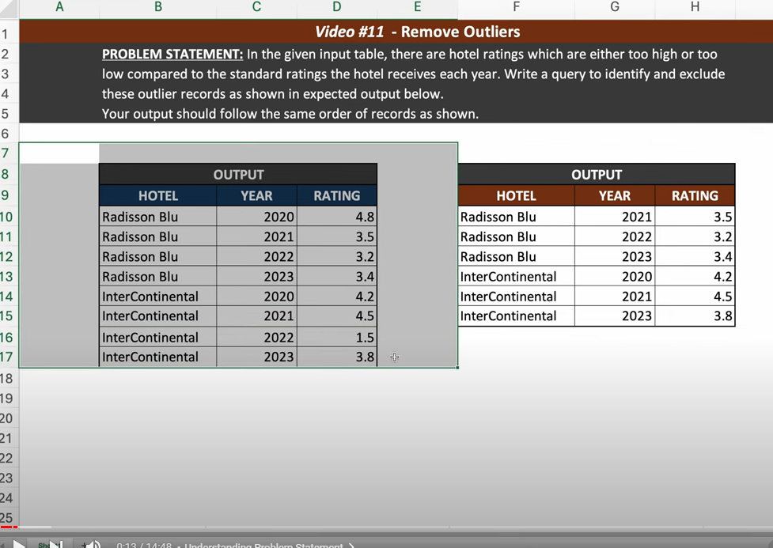

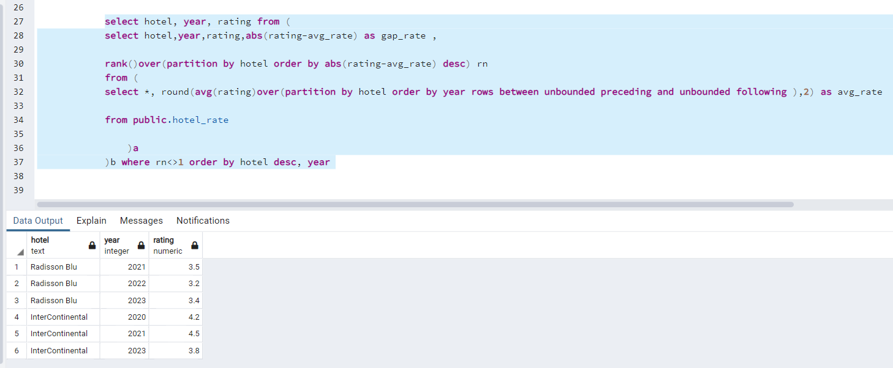

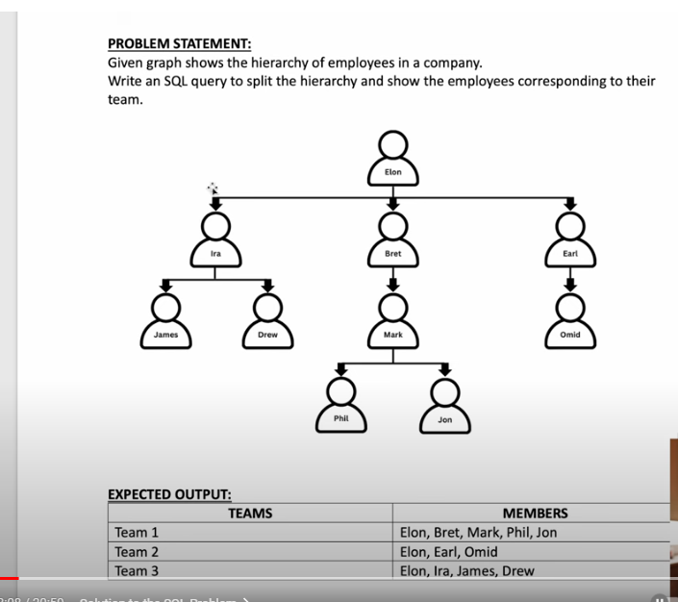

Observe the feature of the output records, found that the sequence is from up to end

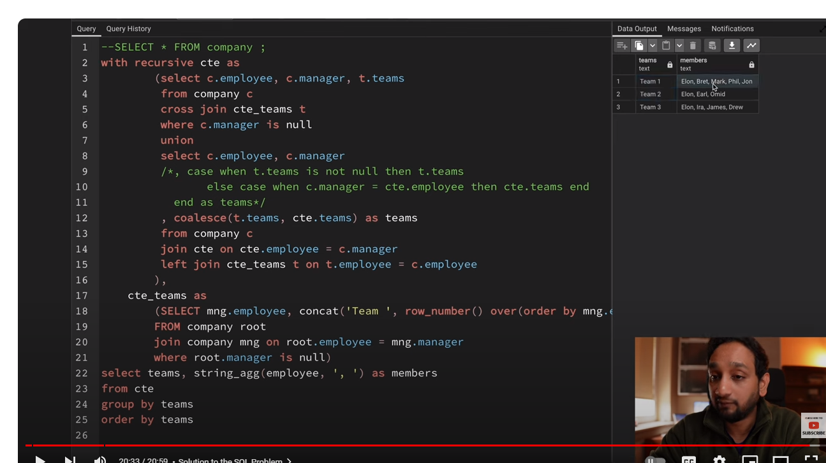

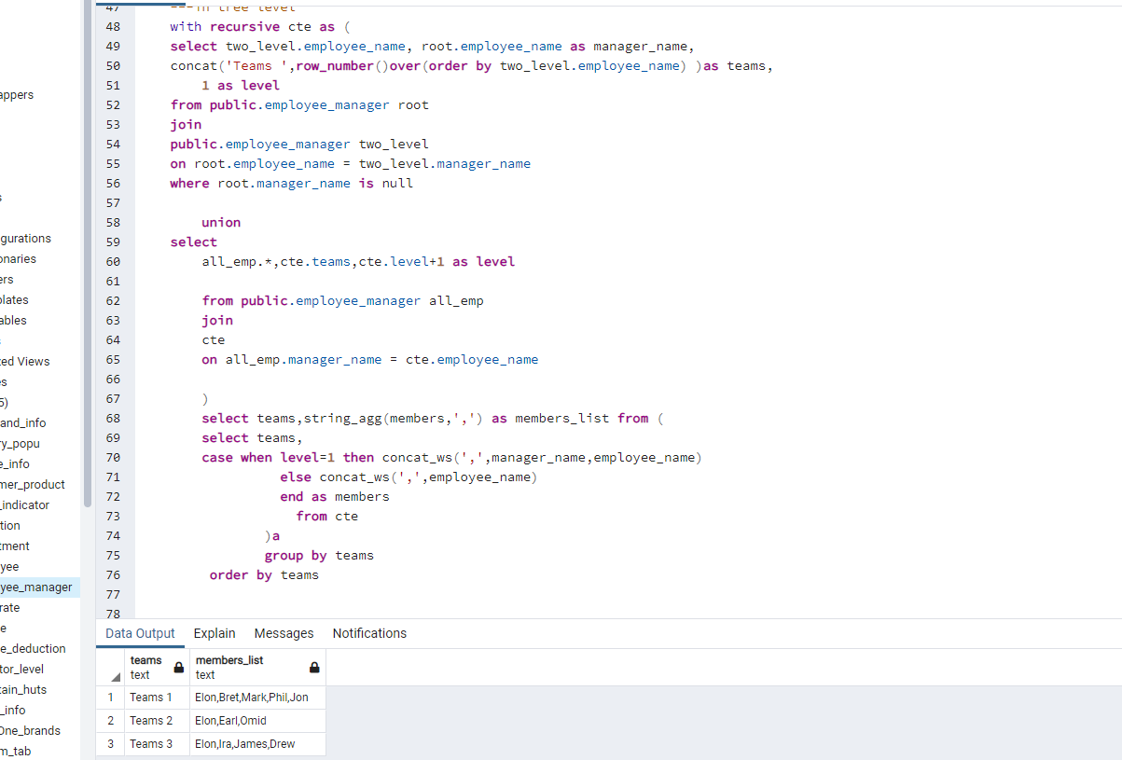

conda install -c anaconda psycopg2

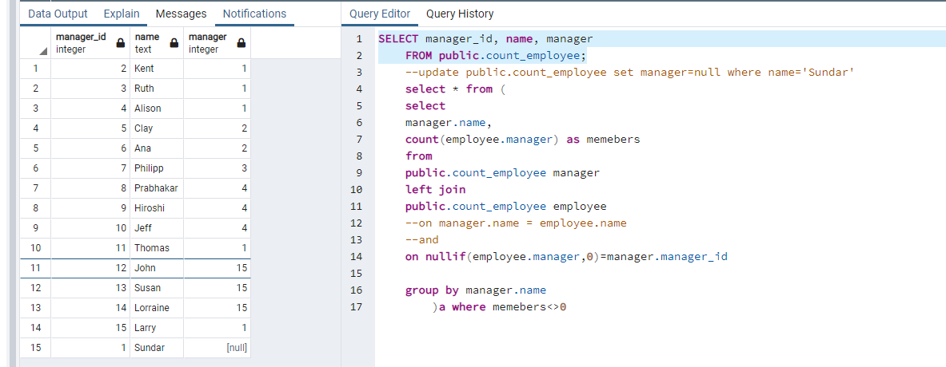

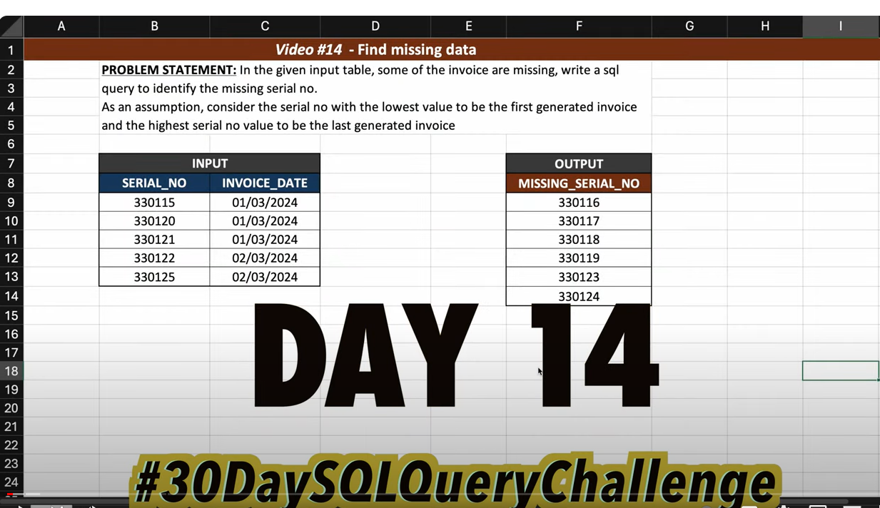

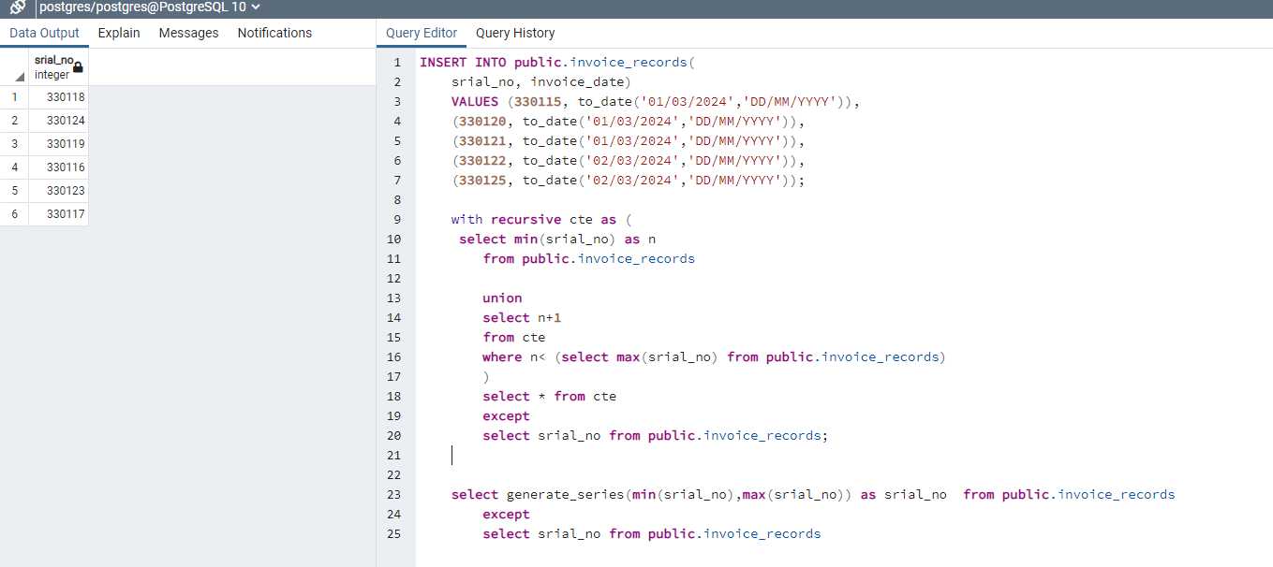

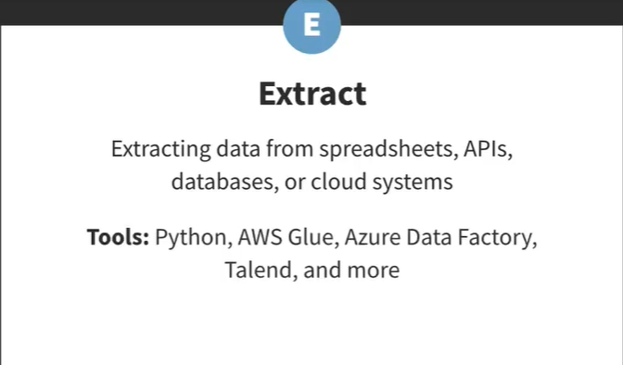

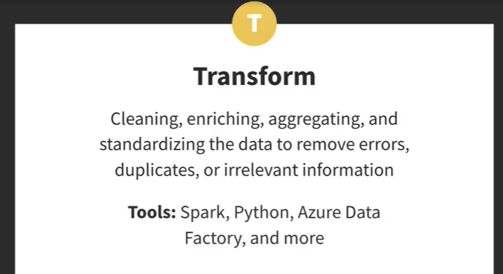

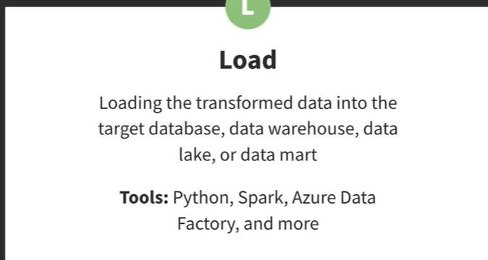

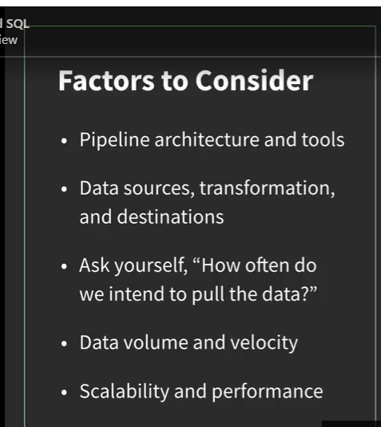

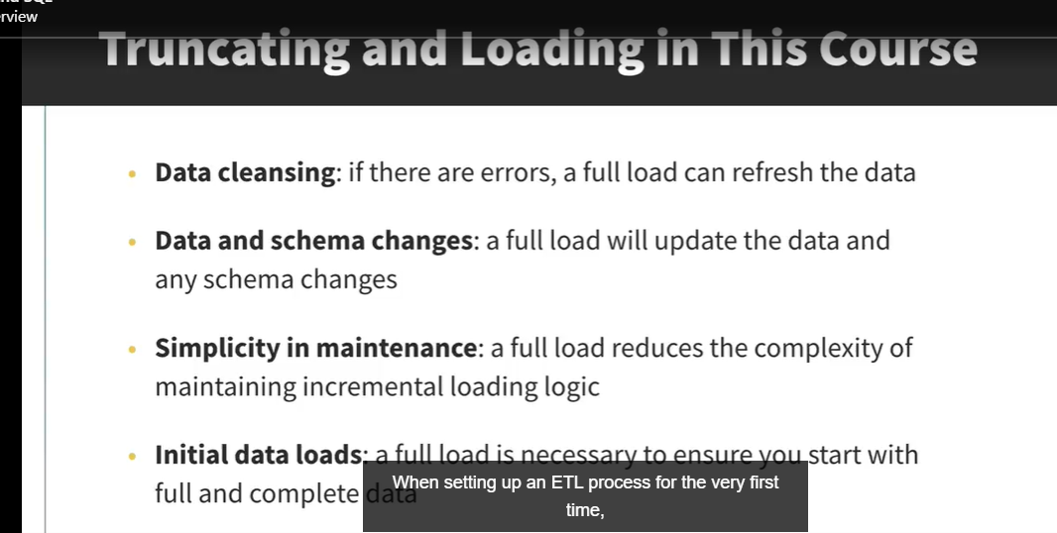

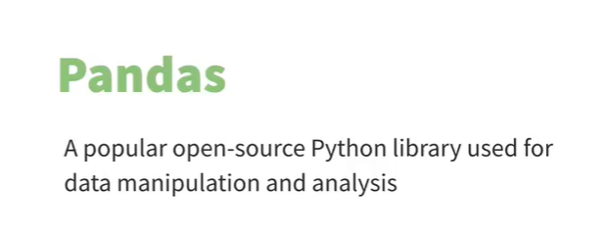

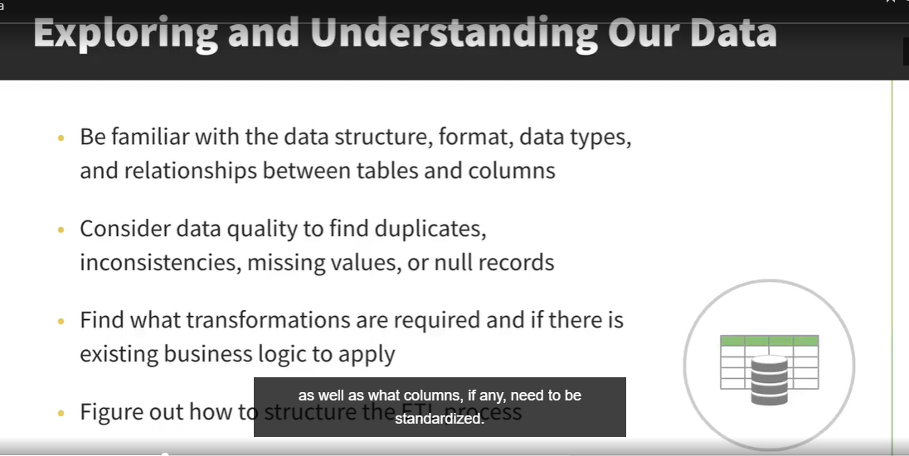

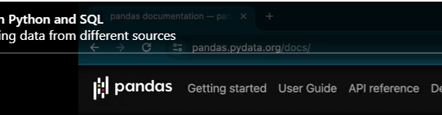

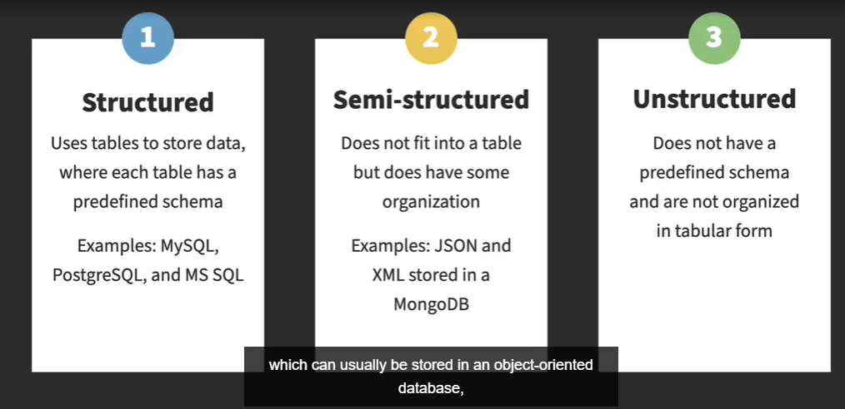

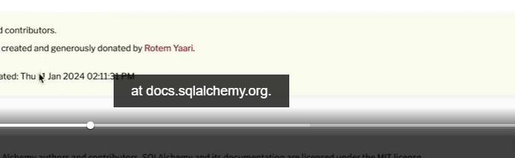

Pip install apache-airflow

Airflow d binit







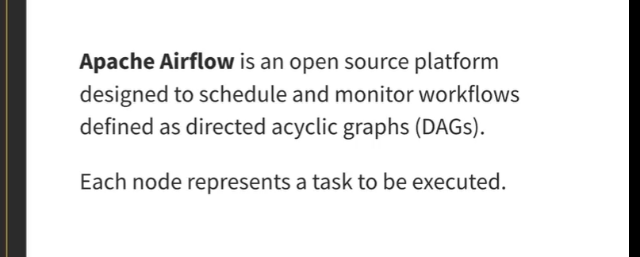

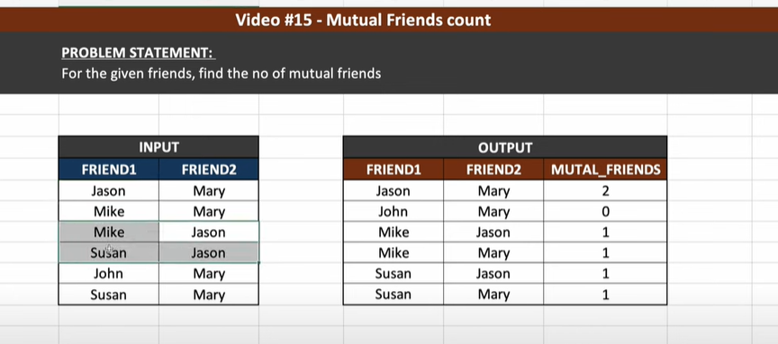

Get consecutive logins spanned 5 days or more, and get start_date, end_date:

INSERT INTO public.user_active(

user_id, login_date)

VALUES (1 ,cast('2024-03-01' as date)) ,

(1 ,cast('2024-03-02' as date)) ,

(1 ,cast('2024-03-03' as date)) ,

(1 ,cast('2024-03-04' as date)) ,

(1 ,cast('2024-03-05' as date)) ,

(1 ,cast('2024-03-06' as date)) ,

(1 ,cast('2024-03-07' as date)) ,

(1 ,cast('2024-03-08' as date)) ,

(1 ,cast('2024-03-09' as date)) ,

(1 ,cast('2024-03-10' as date)) ,

(2 ,cast('2024-03-02' as date)) ,

(2 ,cast('2024-03-03' as date)) ,

(2 ,cast('2024-03-04' as date)) ,

(2 ,cast('2024-03-04' as date)) ,

(2 ,cast('2024-03-05' as date)) ,

(2 ,cast('2024-03-06' as date)) ,

(2 ,cast('2024-03-07' as date)) ,

(2 ,cast('2024-03-08' as date)) ,

(2 ,cast('2024-03-09' as date)) ,

(3 ,cast('2024-03-10' as date)) ,

(3 ,cast('2024-03-11' as date)) ,

(3 ,cast('2024-03-12' as date)) ,

(3 ,cast('2024-03-13' as date)) ,

(3 ,cast('2024-03-15' as date)) ,

(3 ,cast('2024-03-16' as date)) ,

(3 ,cast('2024-03-17' as date)) ,

(1 ,cast('2024-03-17' as date)) ,

(1 ,cast('2024-03-18' as date)) ,

(1 ,cast('2024-03-19' as date)) ,

(1 ,cast('2024-03-20' as date)) ,

(1 ,cast('2024-03-21' as date)) ,

(1 ,cast('2024-03-22' as date)) ,

(1 ,cast('2024-03-23' as date)) ,

(4 ,cast('2024-03-12' as date)) ,

(4 ,cast('2024-03-13' as date)) ,

(4 ,cast('2024-03-14' as date)) ,

(4 ,cast('2024-03-15' as date)) ,

(4 ,cast('2024-03-16' as date)) ,

(4 ,cast('2024-03-17' as date)) ,

(4 ,cast('2024-03-18' as date)) ,

(5 ,cast('2024-03-16' as date)) ,

(5 ,cast('2024-03-18' as date)) ,

(5 ,cast('2024-03-18' as date)) ,

(6 ,cast('2024-03-18' as date)) ,

(6 ,cast('2024-03-18' as date)) ,

(6 ,cast('2024-03-19' as date)) ,

(6 ,cast('2024-03-20' as date)) ,

(6 ,cast('2024-03-20' as date)) ,

(6 ,cast('2024-03-22' as date)) ,

(6 ,cast('2024-03-22' as date)) ,

(6 ,cast('2024-03-24' as date)) ;

select * from public.user_active;

with user_logins as (

select

user_id,

login_date,

date_group,

b.gap_day,

count(date_group)over(partition by user_id,date_group order by user_id, date_group) as day_count

from (

select user_id,login_date,

(fol_login_dt-login_date) as gap_fol,

(login_date - pre_login_dt) as gap_pre,

gap_day,

login_date-gap_day::int as date_group

from (

select

user_id,

login_date,

lag(login_date)over(partition by user_id order by login_date) as pre_login_dt,

lead(login_date)over(partition by user_id order by login_date) as fol_login_dt,

dense_rank()over(partition by user_id order by login_date) as gap_day

from public.user_active

order by user_id,login_date

)a

)b order by user_id,login_date,

date_group ,b.gap_day

),

login_start_end as (

select distinct user_id,date_group,

min(login_date)over(partition by user_id,date_group order by user_id,date_group) as start_date,

max(login_date)over(partition by user_id,date_group order by user_id,date_group) as end_date,

min(gap_day)over(partition by user_id,date_group order by user_id,date_group) as start_gap,

max(gap_day)over(partition by user_id,date_group order by user_id,date_group) as end_gap

from user_logins

where day_count>=5 order by user_id

),

day_gaps as (

select user_Id,start_date,end_date,(end_date-start_date)+1 as daygaps

from

login_start_end

)

select * from day_gaps where daygaps>=5

order by user_id,start_date

;

